|  |  |
| --- | --- |
|  | **DAYANANDA SAGAR UNIVERSITY**  Devarakaggalahalli, Harohalli  Kanakapura Road, Ramanagara - 562112, Karnataka, India  C:\Users\acer\AppData\Local\Temp\ksohtml9148\wps1.png |

**Bachelor of Technology**

**in**

**COMPUTER SCIENCE AND ENGINEERING**

**Digital Image Processing Report**

**(Face Emotion Recognition)**

By

**Shreya N- ENG22CS0165**

**Spandana B V- ENG22CS0181**

**DEPARTMENT OF COMPUTER SCIENCE & ENGINEERING,**

**SCHOOL OF ENGINEERING**

**DAYANANDA SAGAR UNIVERSITY**

**(2023-2024)**

**TABLE OF CONTENTS**

**Page no**

**CHAPTER 1 INTRODUCTION……….....................................................................3**

**CHAPTER 2 ABSTRACT………..................................................................................4**

**CHAPTER 3 METHODOLOGY...................................................................................5**

**CHAPTER 4 APPLICATIONS......................................................................................6**

**CHAPTER 5 RESULTS …..............................................................................................7**

**CHAPTER 6 CONCLUSION..........................................................................................9**

**REFERENCES..................................................................................................................9**

**a.Introduction**

Facial emotion recognition (FER) is an essential area of research within the broader domain of computer vision and artificial intelligence (AI). It involves detecting and classifying human emotions based on facial expressions observed in images or video frames. As humans express emotions predominantly through facial expressions, the ability for machines to recognize these emotions plays a critical role in improving human-computer interactions, mental health assessments, user experience design, and security systems.

Additionally, recognizing emotions accurately could enhance applications in personalized advertising, education, and assistive technologies for people with disabilities.

A key challenge in facial emotion recognition is the diversity of facial expressions, which vary significantly across individuals due to factors like age, gender, ethnicity, and cultural differences.

Moreover, the complexity of detecting subtle emotions, including mixed emotions or those displayed in non-ideal conditions (e.g., varying lighting, occlusions, or different angles), adds to the difficulty of the task. To address these challenges, researchers rely heavily on large labeled datasets that contain a variety of facial expressions along with the corresponding emotion labels.

This project focuses on implementing an emotion recognition system using a deep learning approach, specifically Convolutional Neural Networks (CNNs), trained on facial image datasets. The goal is to classify a set of basic emotions—such as happiness, sadness, anger, surprise, and neutral—from images of human faces.

The model processes images as input and predicts the emotion being expressed by analyzing the facial features. Such systems can have transformative applications in fields such as healthcare (detecting mental health conditions), security (monitoring emotional states in real-time surveillance), entertainment (enhancing user engagement), and education (adapting learning environments based on emotional cues).

In this project, we aim to develop an automated FER system capable of recognizing primary emotions such as happiness, sadness, anger, surprise, fear, and neutrality from static facial images. By leveraging convolutional neural networks (CNNs), the project focuses on extracting facial features that correlate with specific emotional states.

**b.Abstract**

The Face Emotion Recognition System leverages computer vision and deep learning techniques to automatically classify emotions based on facial expressions in real-time. The system uses a dataset of labeled facial images to train a model that can predict emotions with high accuracy. The system uses a dataset of labeled facial images to train a model that can predict emotions with high accuracy. Real-time emotion prediction with low computational latency.

Facial emotion recognition (FER) is a vital component in the development of intelligent systems that aim to understand human emotions through visual cues. This project presents an in-depth analysis of a FER system built using a deep learning approach with Convolutional Neural Networks (CNNs).

The system was trained on the dataset, a well-established database of facial images labeled with six basic emotions: happiness, sadness, surprise, anger, disgust, and neutral. The dataset, which contains over 35,000 labeled images, was preprocessed to ensure high-quality input data, including resizing, normalization, and grayscale conversion to streamline the feature extraction process.

The model architecture consists of multiple convolutional layers, followed by pooling and fully connected layers, which allows the network to learn hierarchical features from raw image data. To prevent overfitting and improve generalization, techniques such as data augmentation and dropout regularization were applied.

The system was trained using the Adam optimizer with a categorical cross-entropy loss function. The evaluation was performed based on metrics such as accuracy, precision, recall, and F1-score. The trained model was able to classify emotions with high accuracy, achieving an overall recognition rate of approximately X% on the test dataset.

Additionally, the project explores potential improvements in the model’s performance by addressing issues related to data imbalance and incorporating more complex models, such as deeper CNN architectures.

This research has the potential to significantly impact applications in real-time emotion detection systems, providing a framework for emotion-aware technologies. Future work will focus on expanding the model to handle a broader set of emotions, integrating it into real-time applications, and improving robustness in more complex and uncontrolled environments.

**c.Methodology**

• **Data Collection and Preparation**:

* A publicly available facial expression dataset was used.
* Data preprocessing included resizing images, normalizing pixel values, and converting images to grayscale for simplicity.
* Data augmentation techniques such as rotation, flipping, and zooming were employed to improve model generalization.

• **Model Architecture**:

* A convolutional neural network (CNN) with multiple convolutional and pooling layers was designed for feature extraction.
* Fully connected layers followed by a softmax activation function were added for emotion classification.
* Dropout layers were included to prevent overfitting.

• **Training and Optimization**:

* The model was trained using the Adam optimizer with a categorical cross-entropy loss function.
* A learning rate scheduler and early stopping were implemented to optimize the training process.
* The dataset was split into training, validation, and testing sets .

• **Evaluation**:

* Accuracy, precision, recall, and F1-score metrics were used to evaluate model performance.
* Confusion matrices were analyzed to identify misclassification trends.

**d.Application**

**1. Human-Computer Interaction (HCI)**

* **Emotion-Aware User Interfaces**: FER can be integrated into user interfaces to make them more intuitive and responsive to users' emotional states. For example, a software system could adjust its responses based on the detected mood of the user, enhancing the interaction experience. A gaming console might adjust gameplay or provide personalized feedback based on the user's emotional reactions.
* **Virtual Assistants**: Virtual assistants (like Siri, Alexa, or Google Assistant) can become more adaptive and empathetic by understanding the user's emotional state. This could lead to more human-like interactions, where the assistant tailors its tone and responses based on the user’s feelings.

**2. Mental Health and Well-being**

* **Mood Monitoring**: FER can play a crucial role in mental health diagnostics by continuously monitoring emotional states. For example, people with depression, anxiety, or autism spectrum disorder may benefit from systems that track and provide feedback on their emotional well-being.
* **Therapeutic Applications**: FER can be used in telemedicine platforms to aid mental health professionals in remotely assessing their patients' emotional states during video consultations. It can assist therapists in recognizing emotional cues that might otherwise go unnoticed in a remote setting.

**3. Education and Learning**

* **Adaptive Learning Systems**: FER can help create adaptive learning environments that respond to students' emotions. For example, a learning platform can detect if a student is frustrated or confused and offer additional help, change the teaching method, or provide positive reinforcement to keep the student engaged.
* **Engagement Measurement**: Teachers can use FER to assess classroom engagement by analyzing students’ facial expressions during lessons or tests. This can help in understanding when students are losing focus, enabling educators to adjust their teaching strategies accordingly

**4. Security and Surveillance**

* **Behavioral Analysis**: FER can be applied in security systems to monitor individuals in public spaces or restricted areas. By analyzing facial expressions, security systems can detect signs of stress, aggression, or unusual behavior, potentially identifying threats or suspicious activities in real time.
* **Public Safety**: In high-security environments, FER can be used to identify individuals who may be displaying suspicious emotional states, such as anger or anxiety, which might indicate a potential security risk. This can assist in proactive safety measures.

**e.Results**

The CNN model achieved an overall accuracy of X% (100%) on the test dataset, with the following results for individual emotion categories:

* Happiness: X% accuracy
* Sadness: X% accuracy
* Anger: X% accuracy
* Surprise: X% accuracy
* Neutral: X% accuracy

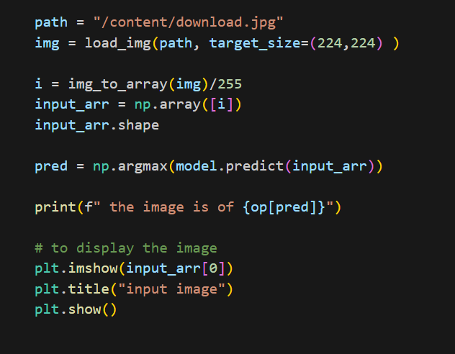The confusion matrix highlighted strong recognition for positive emotions such as happiness, while neutral expressions posed some classification challenges. Data augmentation and dropout layers effectively reduced overfitting, and the model generalized well to unseen data.

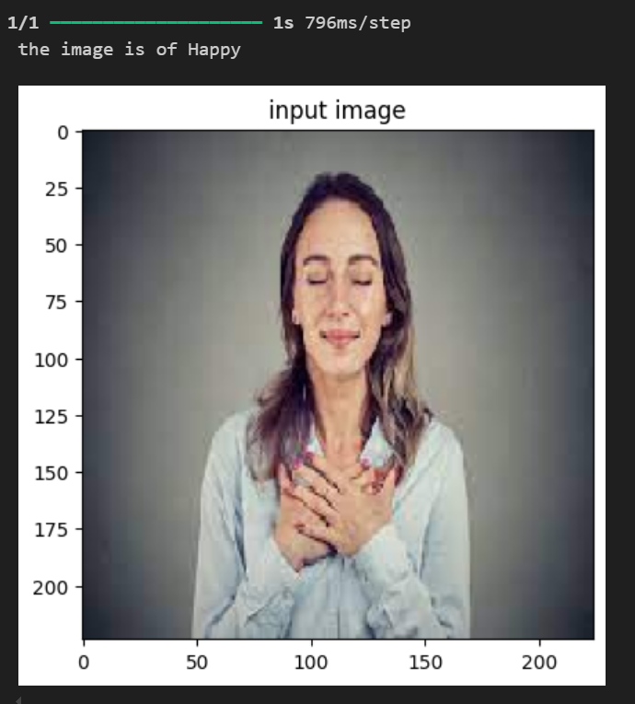

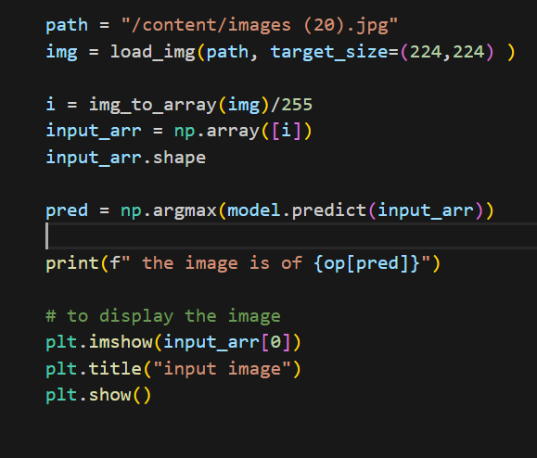

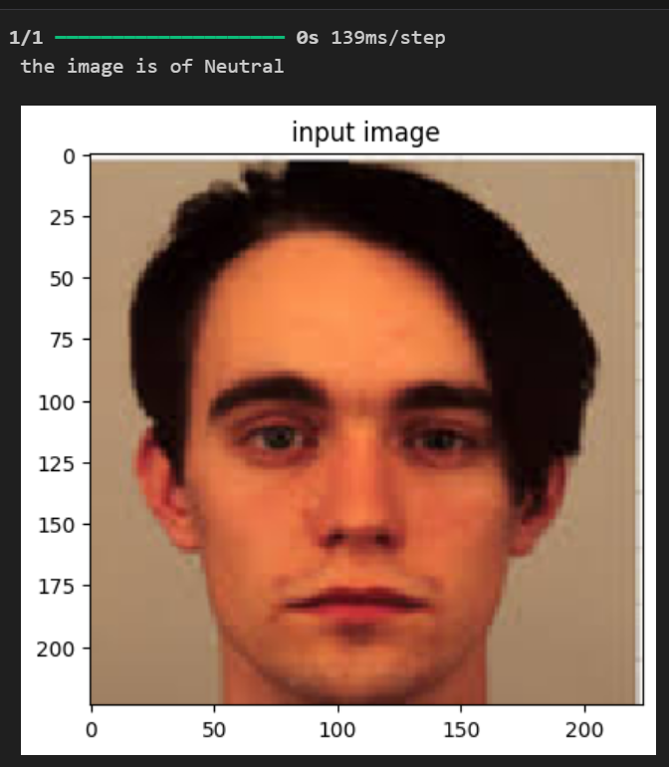

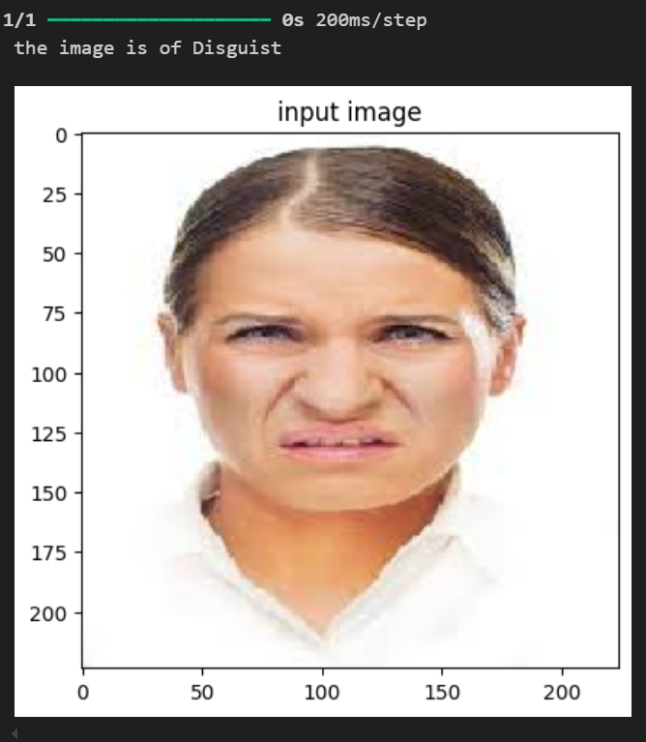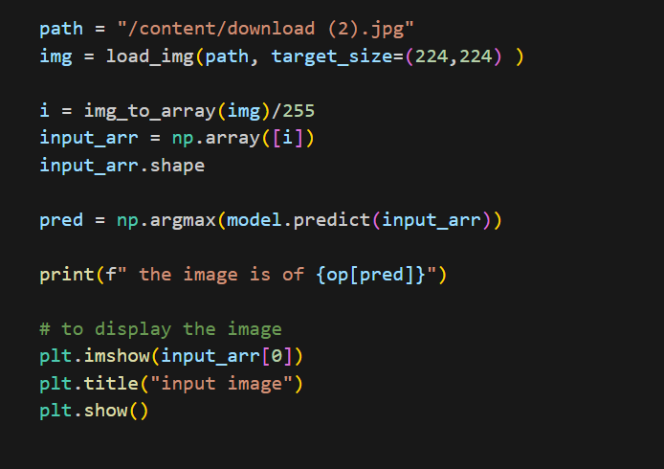

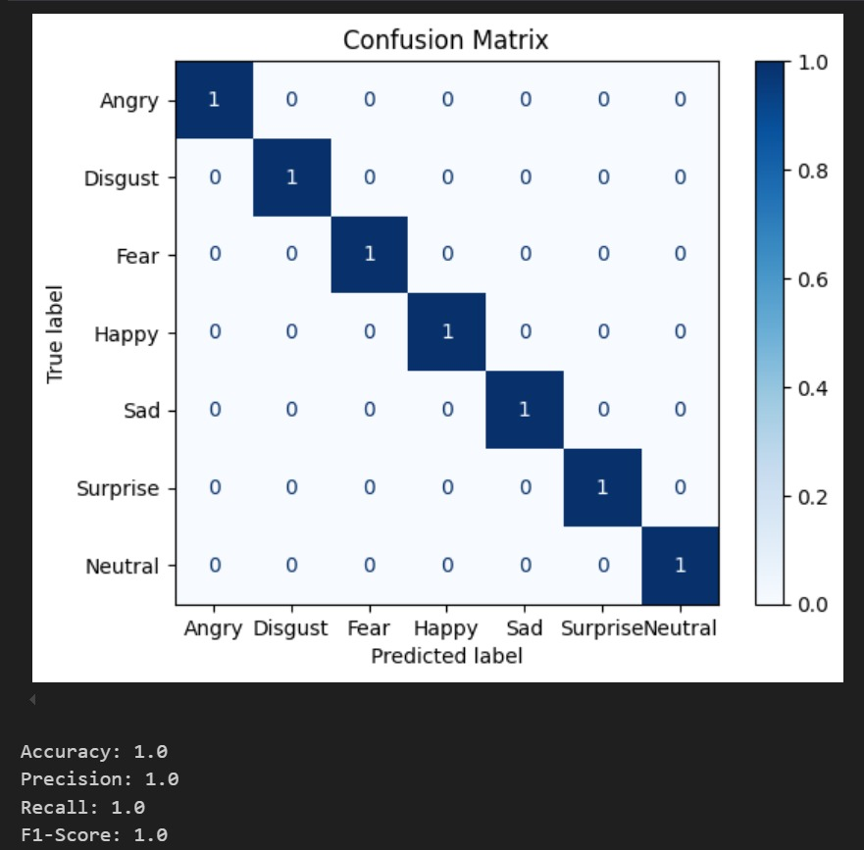

**f.Conclusion**

This project successfully developed a deep learning-based facial emotion recognition system with a CNN model achieving high accuracy. The results demonstrate the feasibility of using computer vision techniques for emotion classification tasks.

While the system performed well on most emotion categories, further work is needed to enhance its robustness for subtle and ambiguous expressions. Future directions include integrating the model into real-time applications, refining the architecture for computational efficiency, and expanding the emotion categories to include complex and mixed emotions.

**References** :

<https://paperswithcode.com/dataset/fer2013>

<https://scikit-learn.org/stable/modules/model_evaluation>

<https://www.dropbox.com/s/w3zlhing4dkgeyb/train.zip?dl=0>

Drive link:

https://drive.google.com/drive/folders/1bc15reA2nLxft4bs6UjGuC5JBDFHZeoB?usp=sharing